Programming Fundamentals Assignment

# Name: KHAWAJA IRTAZA AHMED

# ID: F2023065202

# Section: W5

# Task:

Design a menu based calculator in C++.

# Code:

//PREPROCESSOR

#include <iostream>

using namespace std;

//MAIN

int main ()

{

//DECLARATION

float a, b, result;

int mode;

cout<<"-----MENU BASED CALCULATOR-----\n Enter 1 for sum.\n Enter 2 for subtraction.\n Enter 3 for multiplication. \n Enter 4 for division. \n Enter mode : ";

cin>>mode;

//INVALID MODE DETECTION

if((mode<1)||(mode>4))

{

cout<<" Invalid mode. Enter a mode between 1-4.";

}

//CALCULATION ELEMENT

else

{

cout<<" Enter 1st number: ";

cin>>a;

cout<<" Enter 2nd number: ";

cin>>b;

if(mode==1)

{

result=a+b;

cout<<" Result = "<<result;

}

else if(mode==2)

{

result=a-b;

cout<<"Result = "<<result;

}

else if(mode==3)

{

result=a*b;

cout<<"Result = "<<result;

}

else

{

result=a/b;

cout<<"Result = "<<result;

}

}

//RETURN

return 0;

}

# Output:

In case of valid mode:

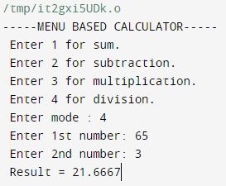

In case of invalid mode:

